For integrating sonarqube ith Jenkins
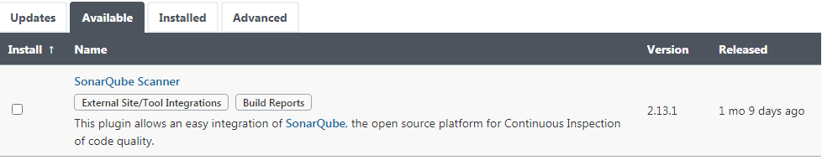
For integrating Docker with Jenins
